**A Mechanistic Model of the Wash Shuffle and Monte Carlo Exploration of its Impact on Card Shuffling in Texas Hold’em**

**Abstract**

In casino games using a standard deck of cards, a wash shuffle is sometimes performed prior to the rest of the card shuffling procedure. Unlike other methods of shuffling, the wash shuffle has not yet been well studied. To this end, we first develop a mechanistic model of the wash shuffle based on our observation of how cards tend to move when a wash shuffle is being performed. Then, we use this model to simulate the card shuffling procedure used in casino poker rooms, and explore the resulting impact on where the cards are dealt in the context of Texas Hold’em poker. We find that while the addition of the wash shuffle does produce probabilities in line with what would be expected from a perfect shuffle in terms of where individual cards will end after the shuffling is performed, it still shows deficiencies in terms of breaking up clumps of cards that have started next to each other, which has significant implications in games like Texas Hold’em in which several cards are dealt face up.

**Keywords:** card shuffling, poker, wash shuffle

**Introduction**

No Limit Texas Hold’em (NLHE) is a game that utilizes an ordinary 52-card deck of cards. Like most card games, an essential facet to the game of NLHE is that the cards are randomized prior to each round of play, or hand, via shuffling. Theoretically, a perfect shuffling procedure would be one in which, after shuffling is performed, every possible ordering of the 52 cards has a 1/52! probability. It has been previously demonstrated that the specific protocol generally used by casino poker rooms to shuffle their decks of cards does not sufficiently randomize the cards, such that the resulting card distributions deviate from that of a perfect shuffling procedure to an extent that can be exploited by players to gain an advantage (Merz & Chi, 2022).

The components of the protocol utilized by casino poker rooms are:

1. Riffle shuffle: The deck is split into two portions of approximately equal size, and then the cards are interleaved back together.
2. Cut: The deck is split into two portions, and the portion originally on the bottom gets placed on top of the portion that was originally on top.
3. Strip shuffle: Also known as a box, this is similar to the aforementioned cut but instead of splitting into two portions, the deck is split into some greater number of portions (typically four), and the portions are placed back together in reverse order.

The protocol in question, referred to as the CS by Merz & Chi (2022), consists of the following, in this order: two riffle shuffles, one strip shuffle, one riffle shuffle, and one cut.

In this work, we investigate an additional shuffling technique that is sometimes utilized prior to the CS, known as the wash. To perform a wash, the dealer spreads out all 52 cards in an arc in front of them, and then rotates each of their hands in opposing circular motions. As the hands move, cards move with them, thus changing the cards’ relative positions until finally the cards are gathered back together. The primary question we aim to answer in this manuscript is: when a wash is performed prior to the CS, how much does this impact the exploitability of the CS by Texas Hold’em players as demonstrated by Merz & Chi (2022)?

Enroute to an answer to this question, we first develop a mechanistic model of the wash shuffle. Unlike many other shuffling techniques, the wash shuffle has not yet been well-studied or modeled. Our development of such a model is thus an additional contribution of this work to the literature. We then utilize this model to simulate wash shuffles prior to the CS, and investigate the resulting impact on the distribution of cards as they are dealt for Texas Hold’em. We find that while the addition of a wash prior to the CS does result in an improved shuffling procedure by several metrics, it still falls short of a perfect shuffling procedure, specifically in terms of inflated relative frequencies of neighboring cards prior to the shuffle remaining as neighboring cards after the shuffle. Due to the nature of NLHE in which certain cards are dealt face-up, this is a crucial suboptimality of the shuffling procedure that can be exploited by a poker player.

**Literature Review**

The primary component of the CS is the riffle shuffle, which has been studied extensively in the literature. A probabilistic model for the riffle shuffle was first proposed by Gilbert (1955) and then independently by Reeds (1981), and has since been dubbed the Gilbert-Shannon-Reeds (GSR) model. Notably, it has been demonstrated that the GSR model produces deck orderings that accurately reflect what occurs when riffle shuffling is performed by a human (Diaconis, 1988). The GSR model prescribes the following to be performed:

1. The deck is split into two portions, with the dividing point determined according to a Binomial(n=52, p=0.5) distribution. Let A be the size of the top portion and B be the size of the bottom portion.
2. The portions are separated, and cards are dropped probabilistically from each portion into position to form the newly ordered deck. The probability that the first card to drop is from each portion is A/(A+B) and B/(A+B) for portions A and B respectively. After the first card drops, A or B changes its value accordingly, and thus the probabilities update for the next card. Cards continue to drop and the probabilities continue to update, until all cards from both portions have dropped into place.

Utilizing the GSR model, Aldous and Diaconis (1986) investigated how quickly, in terms of the number of iterations of a riffle shuffle, an unshuffled deck moves in distribution towards that of a perfectly shuffled deck (again, one in which every deck configuration has a probability of 1/52!) according to the total variation distance metric. Their investigation concludes with the frequently referenced recommendation that seven riffle shuffles is sufficient to randomize 52 cards, with diminishing returns for each riffle beyond that point.

However, the CS only contains a total of three riffle shuffles, in addition to a strip shuffle and a cut, which clearly falls short of the recommendation of seven riffle shuffles. Also, to the best of our knowledge, the CS is universally used in casino poker rooms and in major poker tournaments across the world; some examples of professional dealers using the CS are in the 2017 and 2022 World Series of Poker (WSOP), in footage that is available freely online (PokerGO, 2017; PokerGO, 2022). Further evidence as to the ubiquity of the CS was mentioned in (Merz & Chi, 2022), in which it was also demonstrated that the CS leaves a deck in configurations that are exploitable by Texas Hold’em players.

One aspect that was left uninvestigated by Merz & Chi (2022) is the wash shuffle, in which the cards are spread out in front of the dealer and scrambled at random (see e.g. Black, 2020 for a video demonstration). A wash shuffle does not always occur prior to each hand of play; typically, a wash will be performed when a new box of cards is opened, or in some other circumstances such as when a dealer change occurs, or when an error has occurred during the CS process, e.g. as indicated in a 2013 WSOP dealer’s guide that is available on a public-facing website (WSOP, 2013). However, anecdotally, it appears that a wash may also occur before any hand at the dealer’s discretion, such as what can be observed in the 2018 European Poker Tour Monte Carlo Event (PokerStars, 2018).

Unlike the riffle shuffle, the wash shuffle has remained largely unstudied in literature. The only attempt to probabilistically model the wash shuffle that we have been able to find is in an unpublished manuscript (White, 2019). In this manuscript, three probabilistic models are proposed, in order of increasing complexity:

* Shuffling Process A: Cards begin by occupying spaces 1 through *n*, where *n* is the total number of cards. At each step, a random card is chosen, and either moves one step to the left, one step to the right, or stays in place, with probabilities of ¼, ¼ and ½ respectively. If a card moves to an occupied position, it is inserted into the pile of cards currently there at a random position. This is repeated for some specified number of steps, and then all piles are gathered together in order.
* Shuffling Process B: Cards again begin by occupying spaces 1 through *n*. At each step, every card moves a random number of spaces to the right according to independent geometric random variables, and then every card moves a random number of spaces to the left according to the same distribution. When cards enter an occupied position, they are merged with the cards already there by a GSR shuffle. This is repeated for some specified number of steps, and then all piles are gathered together in order.
* Shuffling Process C: This is a generalization of Shuffling Process A into multiple dimensions. For some number of dimensions *d*, cards begin by occupying arbitrary vertices in a *d-*dimensional grid. At each step, choose a random card. With probability ½, it remains at its current vertex; otherwise, with equal probability it will move to any neighboring vertex. If a card moves to an occupied position, it is merged with the cards already there at a random position. This is repeated for some specified number of steps, and then all piles are gathered together in order.

By the author’s own admission, each of these are quite crude models of an actual wash shuffle, and do not come close to being functionally realistic in terms of what actually happens during a wash shuffle. Their purpose was to be starting points for demonstrating particular mathematical properties such as theoretical mixing times and strong stationary times. Conversely, in the present work, our aim is to demonstrate the resulting impact of the wash shuffle on the play of Texas Hold’em via Monte Carlo simulation, and thus we are less restricted to simple models that are mathematically tractable and are only restricted by the complexity of simulation code that we wish to write. Thus, we will not directly consider any of these models described above, and instead formulate our own.

**Methodology**

*Simulating the Wash Shuffle: Initial setup*

Consider that a dealer’s wash movement initially spreads a single vector of cards into two overlapping circles. These will be the left and right circles, corresponding to which hand is washing them. We observe that, approximately, the left hand moves the first quarter of cards upward and then the third quarter of cards downward, thus completing the left circle. The right hand moves the fourth quarter of cards upward and then the second quarter of cards downward, thus completing the right circle.

Figure 1. The initial setup of the wash shuffle in the top graphic shown the card deck spread across from start to end. Notation 1A, 1B, 2A, 2B, etc. is given to each section of the card deck as a mean to keep track of the transformations to follow. Once the dealer begins “washing” the deck, it transforms into two overlapping circles. The second graphic shows this depiction but in a matrix structure. As shown in the third graphic above, we can transform the card deck into two separate vectors. This allows for ease of implementation into code while allowing for the randomized switching of cards from one side to the other.

1A

1B

2A

2B

3A

3B

4A

4B

1B

1A

2A

2B

3B

3A

4A

4B

1A

1B

3A

3B

2A

2B

4A

4B

Figure 1 above presents the initial setup. The second diagram in Fig. 1 depicts how the setup of a wash can be thought of as a matrix of four columns. The first and third columns are cycled through by the left hand, and the second and fourth columns are cycled through by the right hand. We note that both structures depicted in Figure 1 will be referred to throughout this manuscript. If a vector is referenced, then it will either be the “left vector” (corresponding to cards moved by the left hand according to the blue arrows) or the “right vector” (corresponding to cards moved by the right hand according to the red arrows). Each completion of a circular movement by a single hand will be referred to as a single wash cycle.

*Truncated Poisson (tPoisson) Distribution*

To generate random variables within the possible range of a card deck, we utilize a truncated Poisson distribution (tPoisson). We appeal to this distribution because its right-skewed nature represents the processes in which we are using it, whereby smaller values should be more likely to occur (as described in more detail below). We truncate it to appropriate values as needed, such as from 1 to 52 when all positive values up to the full size of the deck are possible. In this case, the probability mass function becomes:

$$P\left(X=x\right)=\frac{\frac{λ^{x}e^{-λ}}{x!}}{\sum_{y=1}^{52}{\frac{λ^{y}e^{-λ}}{y!}}}, where 1≤x≤52.$$

Although it would be possible to instead use a Binomial distribution, we would still have to truncate it since we do not want to include 0 as a possible value in any of our situations. Additionally, for any given desired mean value, the truncated Poisson distribution gives us a higher variance than a truncated Binomial distribution would, thus making higher values slightly more likely than they would be with a corresponding truncated Binomial distribution, which better matches what we aim to simulate in each of the instances described further below.

*Roll*

As one hand moves in its circular motion for the wash, cards move with it in a manner depicted in the bottom panel of Figure 1. We prescribe this motion to essentially shift the vector by some number of steps; for example, if the number of steps is four, then the card starting in position 1 moves to position 5; the card starting in position 2 moves to position 6, and so on. Cards that started towards the back of the vector wrap around to move to the front of the vector. This motion continues until the wash cycles are completed. Based on (Black, 2020), we assume that approximately four wash cycles are completed by each hand (for a total of eight wash cycles altogether). The number of steps by which a single wash cycle moves its cards is randomly generated according to a tPoisson distribution, with a minimum of one card and a maximum set by the number of cards in the vector of interest (left or right). That is, for both the left-hand and right-hand cycles, the number of elements by which cards shift is $X\sim tPoisson(λ=3, max=vec_len)$ where *vec_len* is the number of cards in the vector in question.

*Slice*

Within each wash cycle, some cards will move from one vector to the other due to the movement of the dealer’s hands. We call this movement a “slice.” We also distinguish between what we call an “inner slice” and an “outer slice,” whereby an inner slice refers to cards moving from one inner column to the other (i.e. column 2 to column 3 or vice-versa depending on whether it is a left-hand or right-hand wash cycle), and an outer slice refers to cards moving from an outer column to an inner column (i.e. column 1 to column 2 during a left-hand wash cycle, or column 4 to column 3 during a right-hand wash).

We assume that an inner slice will occur more frequently, due to the nature of the hand movement during any given wash cycle, whereby card mingling appears to occur more frequently with cards that are in the middle of the wash space as opposed to the outer area. Specifically, we generate a Bernoulli random variable dictating that an inner slice will occur 70% of the time, with an outer slice occurring the remaining 30% of the time. Then, the number of cards that slice from the donor column into the receiver column is determined by a truncated Poisson distribution with λ=4, and a maximum value equal to the length of the donor column minus two. We subtract two because the cards to be donated come from the middle of the donor column, and we restrict it such that the two bookending cards of the column must remain. The cards that slice from one column to another are always a neighboring grouping of cards because, as seen in (Black, 2020), most cards tend to stick in small groups despite being shuffled around.

*Gathering cards*

Once approximately four cycles have been performed by each hand as noted above, the cards are then gathered back into a single deck. For as long as cards remain in at least one column, we select one of these columns at random with a slight preference for inner columns, and move some number of cards from the selected column to the top of the deck. This number is selected at random from a $Binomial\left(n=L,p=0.5\right)$ distribution, where L is the currently length of the chosen vector. We continue choosing a column and cards from the selected column in this manner until all columns are empty and the deck is full of all 52 cards.

Below is pseudocode for two of the primary functions that perform our simulations, greatly simplified from the actual code. Not included are *roll* and *slice* functions; as described above, the *roll* function simply shifts the position of the cards according to how a dealer’s hand motion, and the *slice* function essentially mimics the motion of a dealer’s hand that will move a cluster of cards together out of its current position in the overall sequence of cards, and into another.

***Algorithm 1:*** *wash*

Input**:** **deck**, cycles

Output**:** shuffled **deck**

Construct **left**: reversed first quarter of **deck** and third quarter of **deck**

Construct **right:** reversed fourth quarter of **deck** and second quarter of **deck**

FOR cycles:

*roll* **left** by TPois(λ=3)

*slice* from **left** into **right**

*roll* **right** by TPois(λ=3)

*slice* from **right** into **left**

*gather* on **deck**

RETURN **deck**

**Algorithm 2:** *gather*

Input: **quarter_1, quarter_2, quarter_3, quarter_4**

Output: final **deck**

**deck** = empty deck

WHILE length(**deck**) < 52:

i = quarter index, chosen at random

k = Binom(n = length(**quarter_i**), p=0.5)

pick k cards from the bottom of ith quarter

add cards to top of deck

END WHILE

RETURN **deck**

**Results**

As in Merz & Chi (2022), we consider a game of Texas Hold’em with six players. Each player is dealt two cards, and then ultimately five cards are dealt face up to comprise the “community cards,” with a face down card (a “burn” card) after the first three and again after the fourth community cards. Thus, the community cards will be the cards in position 14, 15, 16, 18 and 20 in the deck.

We first investigate the behavior of the wash shuffle alone. Simulating 100,000 iterations, we track which cards from the initial state of the deck finish in one of the community card positions after the wash shuffle. We do this in part to ensure that our model for the wash shuffle is reasonable, in the sense that cards from every position should have some positive probability of ending in one of the community card positions. For a perfect shuffle, the distribution of starting positions should be uniform, so we would expect something that deviates from this but not too greatly. Results are shown in Figure 2.

Figure 2. Each panel focuses on a particular card location after the wash shuffle is performed. The x-axis in each panel represents the location of the card prior to the wash shuffle. The y-axis shows estimated probabilities via Monte Carlo simulation, with 100,000 iterations performed in each case.

We notice that there is a consistent pattern where the distribution of each previous position is slightly right skewed, with a noticeable dip around position 45. This indicates that cards starting around position 45 before the wash shuffle is performed have a lower probability of finishing in one of these positions after the wash is performed than cards starting from other positions. Since the ending locations of positions 14, 15, 16, 18 and 20 are all near each other, it is not surprising that these histograms would look similar to each other. Referring to Figure 4, position 45 would be towards the middle of the fourth column. To finish in one of the board card positions, the card would have to be selected towards the end of the gather function procedure, which is more likely to occur for cards in one of the outer columns. Thus, at a very coarse level, it appears that cards around position 45 are likely to finish the wash cycles in one of the inner columns, thus making them less likely to be gathered into position 14.

*Wash Shuffle and Casino Shuffle*

Next, we investigate the performance of the wash shuffle combined with a subsequent casino shuffle, which we will refer to as WCS. Following the rationale in Merz & Chi (2022), we begin by investigating the ending locations of the top five and bottom five cards of the deck prior to any shuffling, as these are possible to be known by nature of the fact that the dealer may tend to place the board cards from the previous hand either on top or on the bottom of the deck prior to shuffling. In Figure 4, we show Monte Carlo estimates of the probabilities of these cards being dealt to any player, as a board card, or as a burn card. While the CS results in probabilities that may deviate quite far from what we would expect from a perfect shuffle, the addition of a wash appears to make a significant improvement on the shuffling routine, as the WCS produces probabilities quite close to what would be expected from a perfect shuffle.

Figure 3. Each panel represents different key locations that cards could be dealt to in a hand of Texas Hold’em, and the cards shown in each panel are the five cards at the top and the bottom of the deck prior to any shuffling. The dotted horizontal lines on each panel represent the percentage that would be expected from a perfectly shuffled deck. All simulations were performed with 100,000 iterations, thus resulting in extremely narrow confidence intervals, shown by the horizontal lines around each point.

*Card neighbors*

Arguably the most crucial finding from Merz & Chi (2022) is that the CS does not adequately separate cards that begin as neighbors, where neighbors are defined as cards that are directly adjacent to each other in the deck. In a game such as Texas Hold’em where several cards are dealt face up in succession, this can give a player a significant amount of information. Here, we investigate whether the addition of a wash prior to the CS mitigates this concern, and to what extent if so.

As in Merz & Chi (2022), we define “cards apart” as difference in the positions of card *x* and card *y*, where card *x* comes before card *y*. For example, if card *x* is in position 15 and card *y* is in position 17, their cards apart value is 2. Figure 5 shows Monte Carlo estimates of the probabilities of each possible value of cards apart after performing the WCS, for cards that begin as neighbors. Figure 6 zooms in on the cards apart values of six or less cards, and includes the aforementioned 7-riffle shuffle (Aldous and Diaconis, 1986). Notably, as all simulations were performed with 100,000 iterations, 95% confidence intervals around these barplot values are extremely narrow, on the order of that seen in Figure 4; more specifically, these values have a margin of error on the order of approximately 0.1%, depending on the exact value of the point estimate. For this reason, we omit them graphically on these two figures. We conclude that while the WCS performs far better than the CS, it is still outperformed by a 7-riffle shuffle, and also still deviates significantly from the values expected from a perfectly shuffled deck.

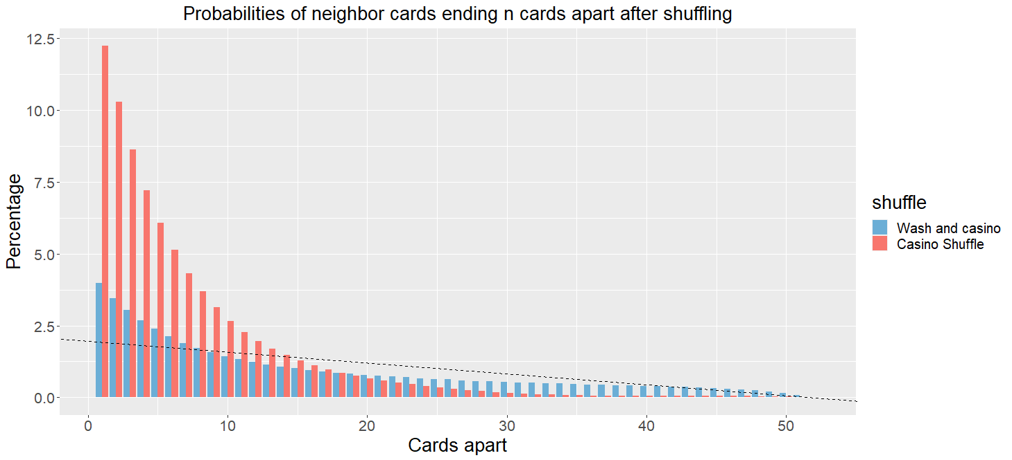

Figure 4. The dotted diagonal line represents the probabilities of each possible value of cards apart that would be expected from a perfect shuffle. The bars show the estimated probabilities via Monte Carlo simulation of each value of cards apart for cards that begin as neighbors, and then a CS or WCS is performed, with 100,000 iterations.

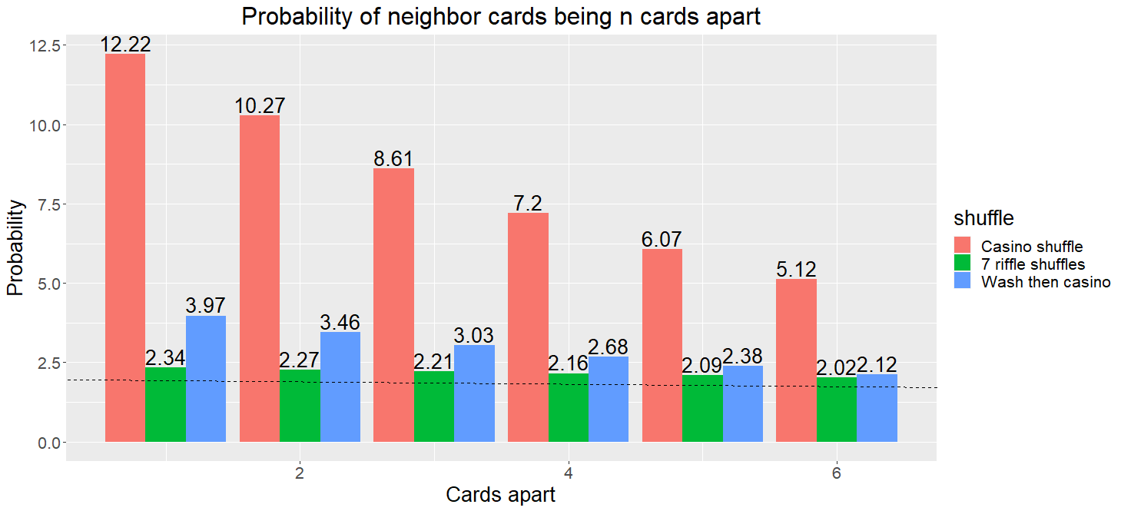

Figure 5. The same information as in Figure 5 is shown here, but specifically for cards apart values of 1 through 6. Again, the dotted line represents the probabilities of each possible value of cards apart that would be expected from a perfect shuffle, and the bars show Monte Carlo estimates of the probabilities of each value of cards apart for cards that began as neighbors and then a CS or WCS is performed. Also shown are the estimated probabilities after performing seven riffle shuffles.

**Discussion**

In this work, we introduce the first realistic model of the wash shuffle ever to be formulated, to our knowledge. We utilize this model to simulate the wash shuffle prior to the CS (i.e. the WCS), and demonstrate the extent to which the WCS is still suboptimal compared to what we would expect from a perfect shuffle.

It is beyond the scope of the present work to derive analytic solutions to theoretical properties of our wash shuffle, such as one-step transition probabilities from one deck configuration to another after performing a wash. However, this could be the focus of future work. Additionally, there is certainly the possibility that other models of the wash shuffle could be developed that would be shown to be more realistic than ours, which could also be an avenue of future exploration.

Here, we show via Monte Carlo simulation that while the WCS does result in approximately correct probabilities of given cards finishing in any given position, it still shows significant deficiencies in separating clumps of neighboring cards. Thus, performing a wash is not a sufficient solution to the failing of the CS to separate clumps of neighboring cards.

Moreover, under current practices, a wash is only rarely performed during the course of play. In the WSOP, as mentioned previously, a wash is only performed when opening a new deck of cards, or when a dealer error has occurred. Additionally, Merz & Chi (2022) recommended performing an additional two riffle shuffles to reasonably mitigate the inflated probabilities of neighbor cards remaining close together in the deck. Anecdotally, a wash shuffle would take more time than this. Thus, assuming that speed is the primary reason that casinos are unwilling to shuffle a deck more thoroughly, we assume that recommending a wash to be added to the shuffling procedure prior to every hand would not be a welcomed solution.

Automatic card shufflers are, in our view, the best solution that satisfies the competing needs for speed and accuracy, even despite deficiencies demonstrated by these machines as well (Diaconis et al., 2013). However, while many poker rooms have adopted them, the monetary cost to purchase these machines has prevented them from being used universally. In particular, for large poker tournaments such as the WSOP, the number of tables required to accommodate all players has meant that most tables in use will not be equipped with automatic card shufflers. Ironically, it is at these large poker tournaments where the monetary stakes can be orders of magnitude higher than most games in a typical poker room, thus meaning that automatic card shufflers are not used where they are arguably more important to be.

**References**

Aldous, D., & Diaconis, P. (1986). Shuffling cards and stopping times. *The American Mathematical Monthly,* *93*(5), 333. doi:10.2307/2323590

Black, J. (2020). How to shuffle cards professionally. *Jack Black Casino Dealer School.* Retrieved from <https://www.youtube.com/watch?v=svi7Jry-KQI&t=344s>

Diaconis, P., Fulman, J. & Holmes, S. (2013). Analysis of casino shelf shuffling machines. *The Annals of Applied Probability*, 23(4), 1692-1720.

Gilbert, E. (1955). Theory of shuffling. Technical memorandum, Bell Laboratories.

Merz, D. W., & Chi, P. B. (2022). Knowing When to Fold'em: A Monte Carlo Exploration of Card Shuffling and How Poker Players Can Gain an Advantage. UNLV Gaming Research & Review Journal, 26(1), 7.

PokerGO. (2017). 2017 WSOP Main Event Day 1. Retrieved from <https://www.youtube.com/watch?v=zdTlTqqtcIk&t=420s>

PokerGO. (2022). 2022 WSOP Main Event Day 6. Retrieved from https://www.youtube.com/watch?v=p6_t9ns9rUw&t=2h4m9s

PokerStars. (2018). Main Event Day 2 - EPT Monte Carlo 2018. Retrieved from <https://www.youtube.com/watch?v=WuNZEccZOsg&t=1917s>

Reeds, J. (1981). Unpublished manuscript.

White, G. (2019). A variation of strong stationary times for random walks with partial symmetries. arXiv preprint arXiv:1910.02389.

WSOP. (2013). 2013 World Series of Poker official dealer guide. Retrieved from <https://www.wsop.com/2013/2013_WSOP_Dealer_Guide.pdf>